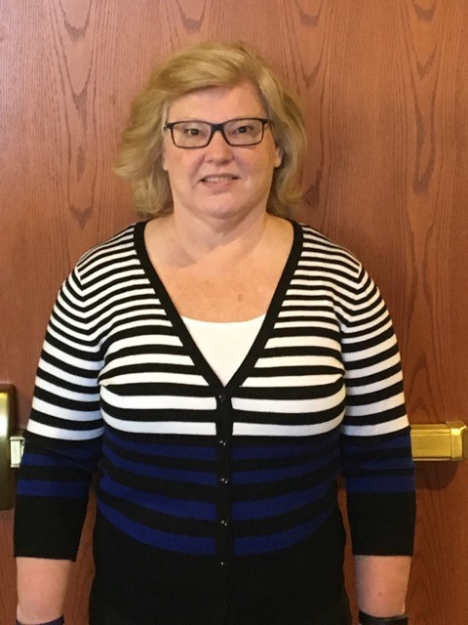

Name: Chrys Frey

Membership in Years: 30 years

Ministry Involvement (Past and Present):
Nursery Volunteer Organized children’s activities for FLC event
Communion Assistant Small group Bible Study co-leader and leader
Scripture Reader JAM Team co-leader
Call Committee member (Next Gen Pastor)
Sunday School Teacher (Pre-K, 1st, 4th, Club 56)
Preparing for the Future Campaign, Advance Commitment Co-chair

What does the Mission of T!LC mean to you?
The Mission of T!LC gives me great pride and hope of belonging to something bigger. My life’s work in education has always supported the idea of empowering others. The Mission statement of T!LC jives with my life in education. Touching the life of one child, one parent, one colleague or one of countless others modeling positive and loving actions, words and deeds is an overwhelming privilege and responsibility. One small gesture, word, smile to one person compounded by the hundreds, even thousands over the years in my life as an educator has hopefully snowballed to countless others. Communicating my beliefs, convictions, morals, life’s story and passions either directly or indirectly over the years has hopefully found a way to impact our community, nation and world.
Over the past 10 years, God has granted me with new life and incredible blessings. I have made some courageous changes personally and professionally. I am convinced that my “servant” role has been re-identified and I will answer His call and serve to the best of my ability where and when He desires. As a leader on earth, I am and will always be a humble follower in His Kingdom.

Describe the gifts and talents that you bring to this ministry:
- Love for Christ
- Life experiences
- Communication
- Common Sense
- Creativity
- Commitment
- Compassion

