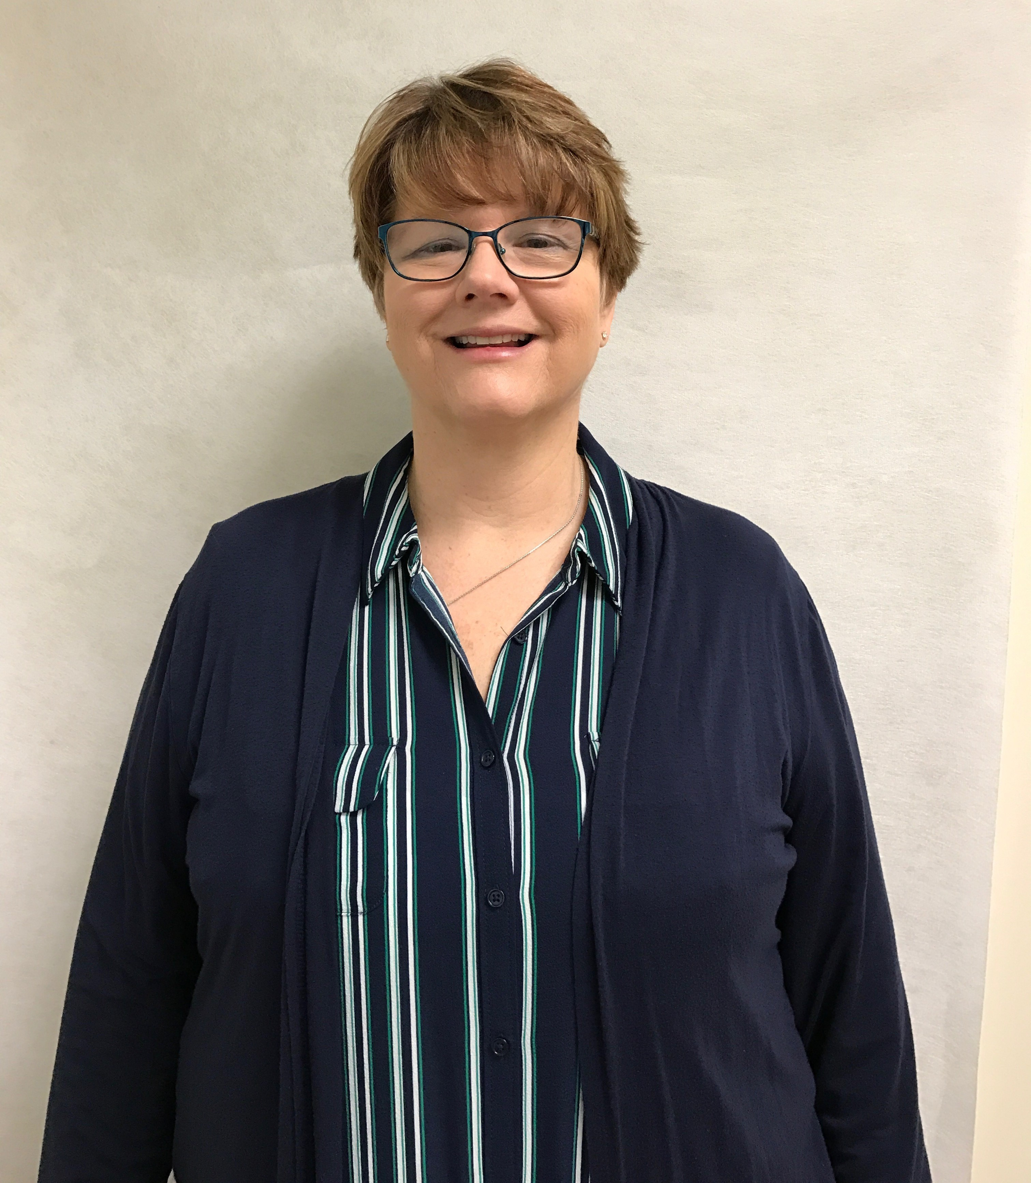

Name: Jan Pasteka

Membership in Years: 24 years (in June 2017)

Ministry Involvement (Past and Present):
T!LC Life Group (Current) Kids Against Hunger Committee Mbr (Current)
Jubilation Team Member (Current) Confirmation Mentor (Current)
Club 56 Volunteer (Current) Prayer & Care Ministry (Current)
AWANA Leader Sunday School Teacher (Pre-k)
Kitchen Remodel Cmte Chair Sunday School Admin Assistant
T!LC Office Volunteer VBS Snack Leader
Funeral Luncheon Volunteer Mom’s-At-Home
Cleansing Stream Dominican Republic Mission Trip
Nursery Volunteer Teens Encounter Christ Retreat
Women’s Retreat Planning Team T!LC Church Picnic Volunteer
Giggles N’ Grins Girl’s Night Out Organizer Silent Retreat
Hospitality Team

What does the Mission of T!LC mean to you?
Bringing people together to know Jesus, promoting fellowship and community, and coming together to show others what Christ looks like.

Describe the gifts and talents that you bring to this ministry:
The gift of being able to talk and visit with all types of folks. God’s given me the eyes to sense people’s hurts and wounds. I am able to reach out and show God’s love and put those folks in touch where they can get connected.
With my love for hospitality I enjoy being able to bring folks together and participate in fellowship. I love this church and I want other folks to see and feel God’s presence here.

