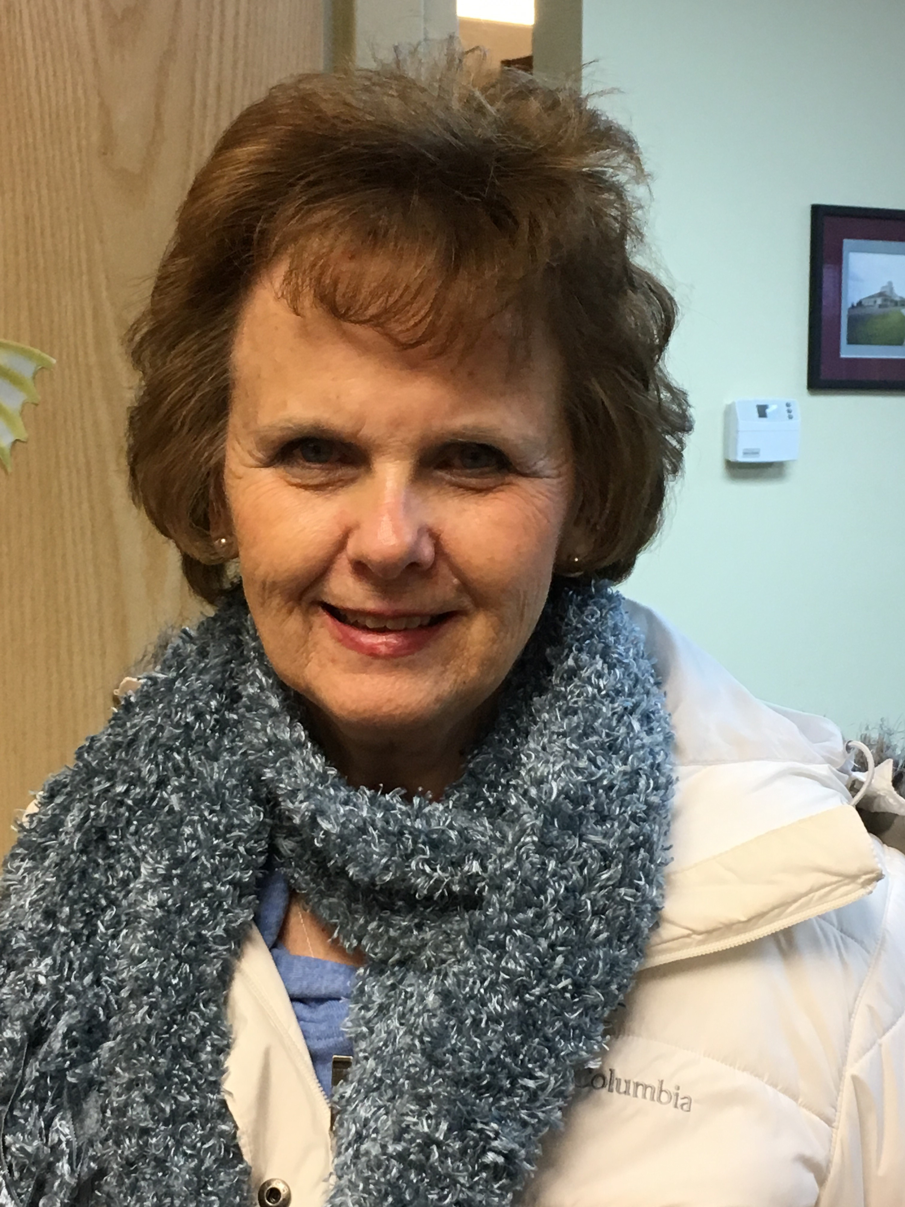

Name: Joyce Pancoast

Membership in Years: 10 years

Ministry Involvement (Past and Present):
AWANA Girls Director (4th & 5th Grade) Alpha Facilitator
Restoring the Foundations – IFM Cleansing Stream Intercessor and Anointer
Discipleship Training Care Ministry
Stephen Minister Barnabas Prayer Ministry
Life Group

What does the Mission of T!LC mean to you?
To be a part of an active church that cares for its people is a great joy to me. T!LC never stands still, but is always seeking a way to bring not only its members, but the community into a relationship with God. T!LC is a relational church that values its leader as well as its lay people. There is always an opportunity presented to expand and deepen anyone’s relationship with God and with each other. We close our doors to no one. I love being a part of a church that helps me expand who I am and who God says I am.

Describe the gifts and talents that you bring to this ministry:
My greatest gift that God has honored me with is the desire to serve in all the ways that the Father opens for me. Each ministry I have served in has given me the skills I need and the tools needed to be a participant in God’s Kingdom. I listen when I need to listen. I don’t depend on my own decisions, but pray for guidance of the Holy Spirit. I am not afraid to be bold where courage is needed, but I’m not fearful of being humble. I am willing to serve where God places me.

